Velocity & Burn-Up Performance Analysis
Metric | Sprint 1 | Sprint 2 | Trend
Velocity (points completed) | 47 | 16 | Down 31 points
Issues completed | 11 | 4 | Down 7
Average points per issue | 4.3 | 4.0 | Stable
Average velocity |  | 31.5 points per sprint
Analysis
- The work was front-loaded. Sprint 1 delivered 47 points, about 59% of the whole project. The team took on most of the foundation work early: the charter, RACI, epics, backlog setup and core system planning.
- The velocity drop reflects sprint size, not slower work. Sprint 2 had fewer issues (4 vs. 11), but the average issue size held steady (4.0 vs. 4.3 points). The team finished everything it committed to in both sprints.
- The burn-up chart shows the team ahead of plan. By the end of Sprint 2, completed work (63 points) is well above the two-thirds mark of 53.3 points. The total-scope line stayed flat at 80 points because the CCB deferred the passenger-crowding feature instead of adding it.
- Sprint 3 is well within capacity. 17 points remain. That is just above Sprint 2's velocity of 16 and far below the 31.5-point average, so the team can finish before the Nov 20 pilot launch.
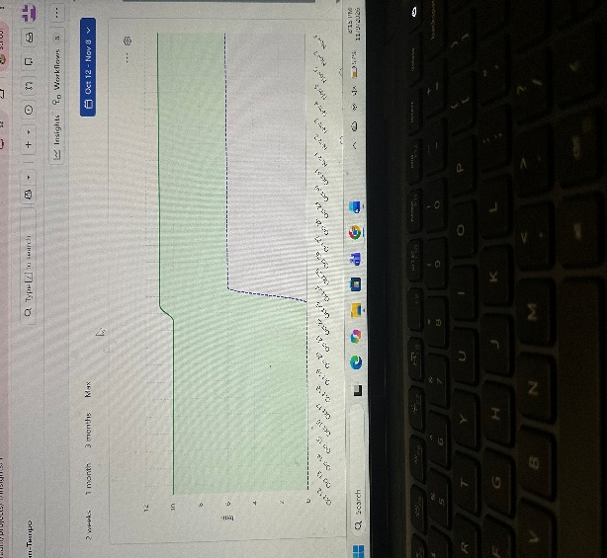
Earned Value Management (EVM) Calculations
Metric | Formula | Calculation | Result
Budget at Completion (BAC) | Total story points | 47 + 16 + 17 | 80 pts
Planned Value (PV) | ⅔ × BAC | ⅔ × 80 | 53.33 pts
Earned Value (EV) | Points completed | 47 + 16 | 63 pts
Actual Cost (AC) | ⅔ × BAC | ⅔ × 80 | 53.33 pts
Schedule Variance (SV) | EV − PV | 63 − 53.33 | +9.67 pts
Cost Variance (CV) | EV − AC | 63 − 53.33 | +9.67 pts
Schedule Performance Index (SPI) | EV ÷ PV | 63 ÷ 53.33 | 1.18
Cost Performance Index (CPI) | EV ÷ AC | 63 ÷ 53.33 | 1.18
What it means
- SPI 1.18: The team has completed 18% more work than planned by this point. It is ahead of schedule.
- CPI 1.18: Each unit of budget spent has produced 1.18 units of value. It is under budget.
- Both indexes are above 1.0, which is healthy
Sprint 3 Forecast
Metric | Formula | Calculation | Result
Estimate at Completion (EAC) | BAC ÷ CPI | 80 ÷ 1.18 | 67.72 pts
Estimate to Complete (ETC) | EAC − AC | 67.72 − 53.33 | 14.39 pts
Variance at Completion (VAC) | BAC − EAC | 80 − 67.72 | +12.28 pts
- Forecast: At the current efficiency, the project will finish at about 67.7 points of cost against an 80-point budget, roughly 15% under budget. Sprint 3 should need about 14.4 points of effort to deliver its 17 points of planned work.

